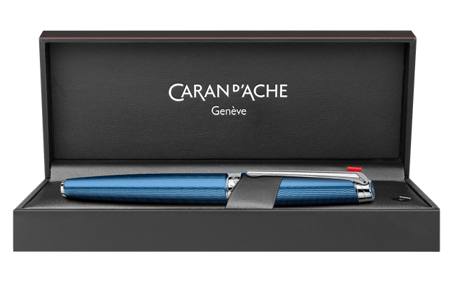

LÉMAN™ GRAND BLEU Roller Pen

CHF 510.00 VAT

Bathed in light and ruffled by the wind, waves come to life with the new Léman™ Grand Bleu. The delicately engraved background evokes the regular ripples of waves on the water's surface. A layer of translucent lacquer, reminiscent of the intense blue of the ocean depths, reveals these undulating reflections on the refined body of Léman™ Grand Bleu writing instruments.Lulled by the waves and the zephyr's song, lovers of fine writing will dive headlong into a thrilling odyssey with the new Léman™ Grand Bleu.